Data Dictionary

Fuel Analysis Project

# Tables

## BGETCHDATA.PTCHTRANH

DB2 table, from AS400 – fuel vendor software

select TRNID, TRNDAT, TRNTIM, TRNTS#, TRNTSN, TRNSTC, TRNST, TRNDRI, TRNUNT, TRNPI1, TRNPQ1, TRNPI2, TRNPQ2, TRNPI3, TRNPQ3, TRNPI4, TRNPQ4, TRNPI5, TRNPQ5, TRNPI6, TRNPQ6 from BGETCHDATA.PTCHTRANH where TRNDAT > 20170000

1. TRNID Transaction ID
2. TRNDAT Transaction Date (YYYYMMDD)
3. TRNTIM Transaction Time (HHMM)
4. TRNTS# Station ID
5. TRNTSN Station Name
6. TRNSTC Station City
7. TRNST Station State
8. TRNDRI Driver Code
9. TRNUNT Unit ID
10. TRNPI1 Item Code 1
11. TRNPQ1 Item Quantity 1
12. TRNPI2 Item Code 2
13. TRNPQ2 Item Quantity 2
14. TRNPI3 Item Code 3
15. TRNPQ3 Item Quantity 3
16. TRNPI4 Item Code 4
17. TRNPQ4 Item Quantity 4
18. TRNPI5 Item Code 5
19. TRNPQ5 Item Quantity 5
20. TRNPI6 Item Code 6
21. TRNPQ6 Item Quantity 6

Actual fuel transactions will have an item code of ULSD or FUEL, CDSL, DSL1, BDSL, and could be in any of the Item slots 1-6

## IBGEFILE.UNITS

DB2 table from TMS vendor

select UNUNIT, UNYEAR, UNMAKE, UNSER from IBGEFILE.UNITS where (UNTERM = 0 OR UNTERM >= 2017001) and UNUNIT NOT LIKE 'T%' and trim(UNUNIT) NOT LIKE '99%'

1. UNUNIT Unit Number
2. UNYEAR Model Year
3. UNMAKE Make
4. UNSER VIN

## BGEIDSC.EF2EFFP

DB2 table from Fuel Optimzation vendor

select * from BGEIDSC.EF2EFFP

1. TRUCK Unit Number
2. ACTIVE Active Flag (for fuel optimization)
3. SENDFUEL Send Fuel Flag (for fuel optimization)
4. SENDROUTE Send Route Flag (for fuel optimization)
5. TANKCAP Tank Capacity (gallons)
6. AVGMPG MPG used for Fuel optimization (real value is closer to 7mpg)

## Extranet2.ExactFuelEvent

SQL Server table, imported from Omnitracs Event Subscriber

Select*fromExactFuelEventswhereEventTimeStamp>='2017-01-01 00:00:00'

1. Id AutoNumber ID
2. ESS_Id Omnitracs Event Subscriber Service **Event Id**
3. EventTimeStamp DateTime of Event (normalized to Central Time)
4. EquipmentID Unit Number
5. MCTNumber Mobile Communications Terminal ID
6. EquipmentType should always read ‘tractor’
7. DriverId Driver Code Assigned to unit at time of reading (varchar(6))
8. Latitude decimal degrees latitude at time of reading
9. Longitude decimal degrees longitude at time of reading
10. LocationTimeStamp DateTime of location reading
11. Speed MPH at time of reading
12. Heading direction of travel at time of reading
13. Odometer unit odometer at time of reading
14. IgnitionStatus 1=on, 2=off
15. EFReportReason 0=ignition on, 1=ignition off, 2=timer

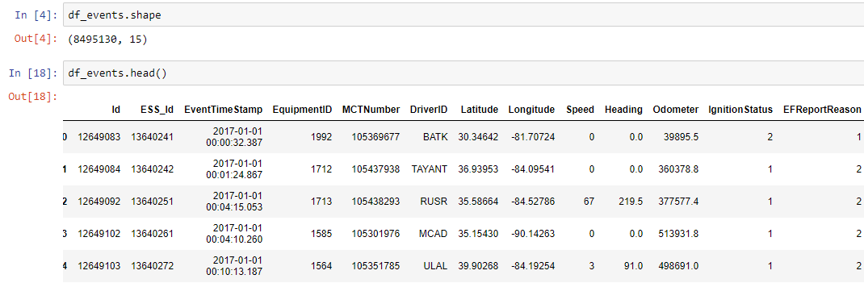

## Extranet2.ExactFuelTankLevel

SQL Server table, imported from Omnitracs Event Subscriber

select ExactFuelTankLevels.*fromExactFuelTankLevelsjoinExactFuelEventsonExactFuelEvents.Id=ExactFuelEventIdwhereEventTimeStamp>='2017-01-01 00:00:00'

1. Id AutoNumber id
2. TankId Tank Sensor # (for our trucks, will always be 1)
3. TankLevelPercent Percentage Reading 0-100.00
4. TankLevelGallons Gallons (Percentage * Tank Capacity) (calculated)
5. ExactFuel**EventId** Foreign Key to ExactFuelEvent

